Project Synopsis — Submission Template
HCLTech Career Shaper Programme | III Year Industry Project | 2025-26

Field | Details (Learner to complete)
Project Title | COVID-19 Data Analysis and Visualisation
Project No. | 48
Domain | Data Analytics / Python
Difficulty | Beginner
Duration | 4 Weeks
Format | Individual Project
Learner Name | Saloni Singh
Roll Number | 2300320130213
College / Campus | ABES Engineering College
Mentor Name | Dipali Kedar
Submission Date | 31 October 2026

1. Problem Statement

Students, analysts and decision-makers who use shared COVID-19 datasets face inconsistent country attributes, impossible values (for example recovered greater than confirmed) and counts that are hard to compare across countries. This matters because unreliable inputs lead to misleading comparisons on a politically sensitive topic. This project audits and cleans a 10-country, 50-day COVID-19 dataset with a documented pipeline, derives standard metrics, and presents them in charts and an Excel dashboard.

2. Proposed Solution & Approach

I built a Python workflow in a Jupyter notebook that audits the raw dataset, standardises continent and population for each country, flags impossible values instead of deleting them, and derives case fatality rate, cases and deaths per 100k, vaccine doses per 100 and recovery rate. The cleaned data is explored with Matplotlib, Seaborn and Plotly charts and presented in an Excel dashboard with PivotTables, PivotCharts and a continent slicer. The audit showed that the file fails basic logic checks (77% of rows flagged) and is likely synthetic, so the pipeline is designed to be re-run on real OWID/WHO data.

3. System Architecture

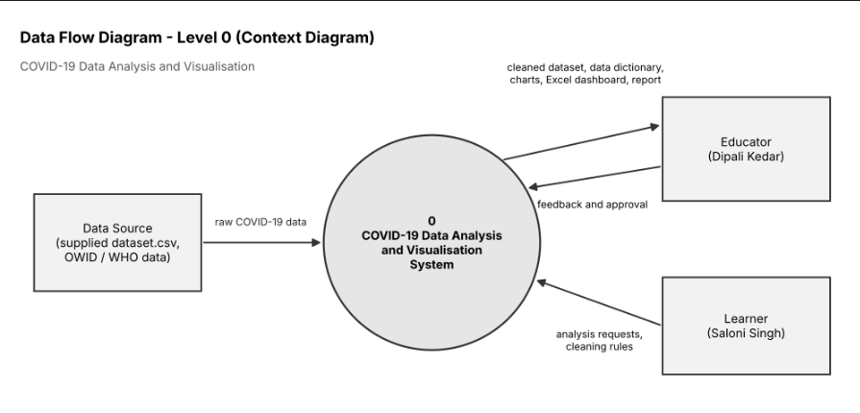

4. Technology Stack

Frontend / UI: Excel dashboard (PivotTables, slicer); Jupyter Notebook

Backend / Logic: Python 3 (Pandas, NumPy)

Database: CSV files (no database server)

AI/ML Framework: Not applicable

Visualisation: Matplotlib, Seaborn, Plotly, Excel PivotCharts

Hardware: Not applicable

5. Dataset Used

Dataset file name: dataset.csv

Number of rows: 500

Number of columns: 8 original, 22 after cleaning

Key columns: date, country, confirmed, deaths, vaccinated

Additional data collected: None (approximate country populations and continents used as a reference table)

6. Key Results & Metrics

Metric 1: Data-quality audit, 385 of 500 rows (77%) flagged with at least one impossible value

Metric 2: Pooled case fatality rate, 1.69%

Metric 3: Visual outputs, 5 notebook charts and 5 Excel charts

Business value achieved: a reusable, documented pipeline that exposes data-quality problems before analysis and presents cross-country metrics in an interactive dashboard.

7. Challenges Faced & How Resolved

Challenge 1: every country had 5 different continent and population values → Resolution: replaced them with one reference value per country.

Challenge 2: recovered was greater than confirmed in 228 rows and deaths greater than confirmed in 9 → Resolution: kept all rows, added flag columns, and computed rates only on plausible rows.

8. References

Our World in Data, COVID-19 data repository, https://github.com/owid/covid-19-data

World Health Organization, WHO COVID-19 Dashboard, https://covid19.who.int

McKinney, W. (2010). Data Structures for Statistical Computing in Python. Proc. 9th Python in Science Conference.

9. Ethical Compliance Declaration
I confirm that:
 All dataset usage complies with the source licence.
No personally identifiable information (PII) is stored without consent.
AI tools used for code/writing are disclosed in the Appendix.
This project complies with the DPDP Act 2023 where applicable.
Learner Signature: Saloni Singh Date: 31 October 31, 2026

